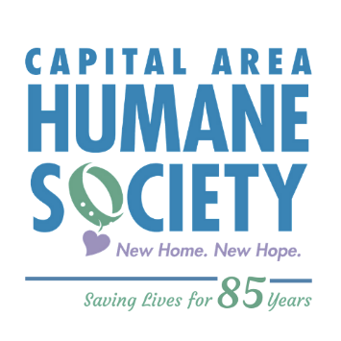

Dear Families,

Thank you for registering for one of our camps at the Capital Area Humane Society this summer! We are looking forward to working with your child and enjoying another great summer of learning and fun!

In these times of uncertainty, we have been busy preparing to offer a safe and enjoyable camp season. Safety is a top priority for all of us at CAHS, and we have implemented many new procedures within our camp program to help keep everyone safe. Please know that CAHS is following all CDC and public health guidelines and recommendations. Below are just some of the measures applied throughout our organization, and are expected of employees, volunteers, and the visiting public.

- Maintain 6 ft. and social distance whenever possible
- Wear face masks within the building at all times
- Clean and sanitize all shared surfaces frequently
- Significantly limit the number of people in the building and in enclosed areas
- Wash and sanitize hands frequently (hand sanitizers are readily available throughout the building)
- Ensure people who are sick stay home
- Work to keep those most vulnerable safe
- Require self-reporting of symptoms/positive tests, and close contact with those who test positive for COVID-19
- Staff required to have temperature taken, with a contactless thermal thermometer, and sanitize before entering the building each day
You might also be interested to know that as an animal shelter, the prevention of disease spread is an essential part of our everyday work. We have an advanced air exchange system designed to reduce the spread of airborne contagious disease. In addition, we have rigorous cleaning, sanitizing, and disinfecting protocols, throughout the organization, using highly effective and completely safe disinfectants.
In regards to camp, we have implemented several program-specific procedures to ensure safety.
These include:
- Camp sessions will have a maximum capacity of 6-10 students
- New seating and activity arrangements to better allow for social distancing
- Daily cleaning and sanitizing of high traffic areas, storage cubbies, tables, chairs, restrooms, countertops, and more
- Utilization of outdoor classroom spaces, whenever possible
- Children will be given their own set of materials to be used throughout the week (i.e. scissors, glue). Non-porous items will be properly sanitized daily. Items that cannot be sanitized, such as crayons and paper, will be sent home with campers at the end of the day/week.
- Drop-off and pick-up procedures will occur outside of the building. Each camper will have their temperature taken, with a contactless thermal thermometer, and be asked to sanitize before entering the building. Parents/guardians will be asked to verbally complete a 5 question Covid-19 screening each morning during drop-off.
- Facial coverings will be required for staff and campers throughout the day. We understand that with young children, they may need breaks and our team is prepared to assist with that, while keeping everyone safe.

Please feel free to reach out with any questions you may have regarding our summer camp program.
Thank you for all you do to support CAHS!

Sincerely,

Lexy Ritenburgh
Programs Manager

